

Logo could double as button instead of begin shift

Begin Shift

User:
Monday July 9, 2012 9:00 PM
Enter Name
Date and time

Free text with keyboard
Drop Down
Scroll to 10
Free text with keyboard
Email:
Enter email

Shift:
Enter Shift #
Slide button--Dictates Rate on Screen 2. Default Patron
Employee/Patron

NEXT
All Fields mandatory to proceed

Lock and Swipe to open. Locks in 5 seconds after Start initiated
Triple digit timer 999 max
We may want to add a scroll to add location of the service as well

Cost of massage: calc based on a predetermined rate based on screen 1 employee/patron button
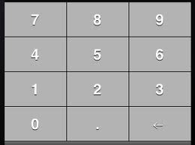
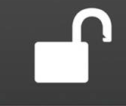

Monday July 9, 2012 9:00 PM
Alarm Sounds on completion
Totals: 300 mins. 11 Massages
15:00
$30.00

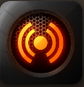
Slide button
Default “No”
Allow Provider to add or delete minutes off the timer
+
Comp: Yes/No
-

START/PAUSE/RESUME
Message:Do you really want to end the shift and email your totals? Click Yes to end Shift otherwise click Cancel to remain on shift. Emails text file to specific email address for importation into xls. Each service being a single line.
Navigation to Final Screen
Message:Do you really want to end the Service? Click Yes to end otherwise click Cancel to continue the service. Navigation to new timer screen, logs the minutes from service and # of service to total bar above timer
STOP/NEXT
END SHIFT

Also allows emails to specific free Text email input on screen 1

Monday July 9, 2012 9:00 PM

Shift Totals: 300 mins. 11 Massages

Thank you. Please drop your phone and funds off to the on-duty Manager.

Resets app to screen 1

RESET APP

Monday July 9, 2012 9:00 PM

